Escape District 34 Guide

Introduction

The Main Menu

The Game Screen

Identify the Pattern

Item Selection

Confirm Pattern

Challenges

Scoring

# Escape District 34 Guide

## Introduction

Escape District 34 is a game designed to challenge your ability to identify patterns. You are wanted by the authorities and have no choice but to escape the country through 34 districts. To avoid the authorities you must disguise yourself among the crowd. Observe the crowd, identify the common pattern. Steal the clothing or items you need and escape each district!

## The Main Menu

## Upon loading the index page, you will see a menu with four buttons. Press the play button to play the game, the Tutorial button to load the tutorial page *(not implemented yet), the Scoreboard button to go to the scoreboard, and the Credits button to go to the Credits screen.

## 

## 

## The Game Screen

Upon entering the game, you will see a line of characters wearing a variety of colourful equipment. Note the labels, pause (red), player/game stats (blue), confirmation button (green), line movement/direction (purple). In addition consider the white box which will display your item selection.

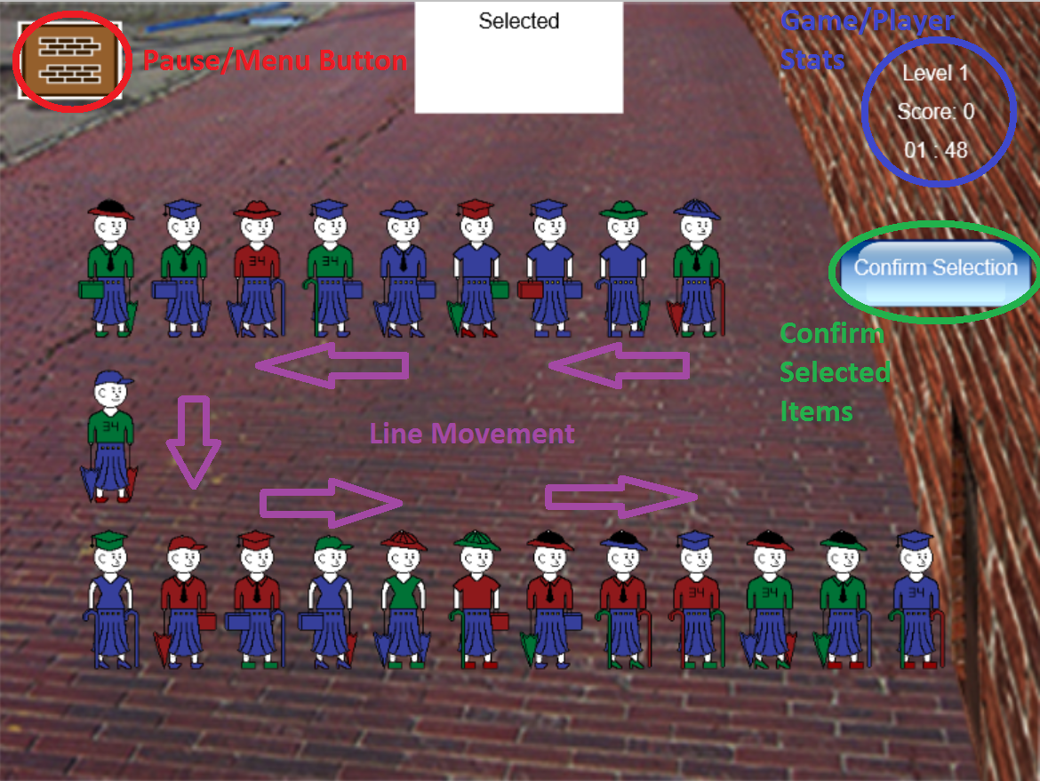

## 

## 

## 

## 

## 

## 

## Identify the Pattern

We need to identify the common item in order to proceed to the next district.

Notice how each person is wearing a **green shirt?**  
Let’s steal that shirt!  
**Click/Touch** on a person to enter their **item selection screen**

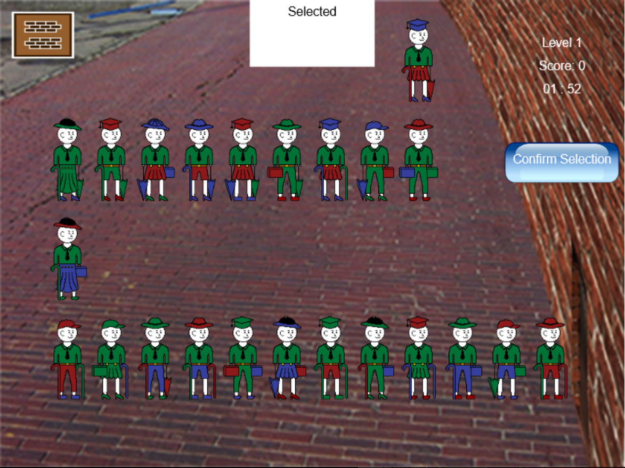

## 

## 

## 

## 

## 

## 

## Item Selection

After **clicking/touching** a person you will arrive at this screen.

Here, we have a boxes corresponding to each item type.

**Click/touch** the desired item you wish to steal… The **green shirt!**

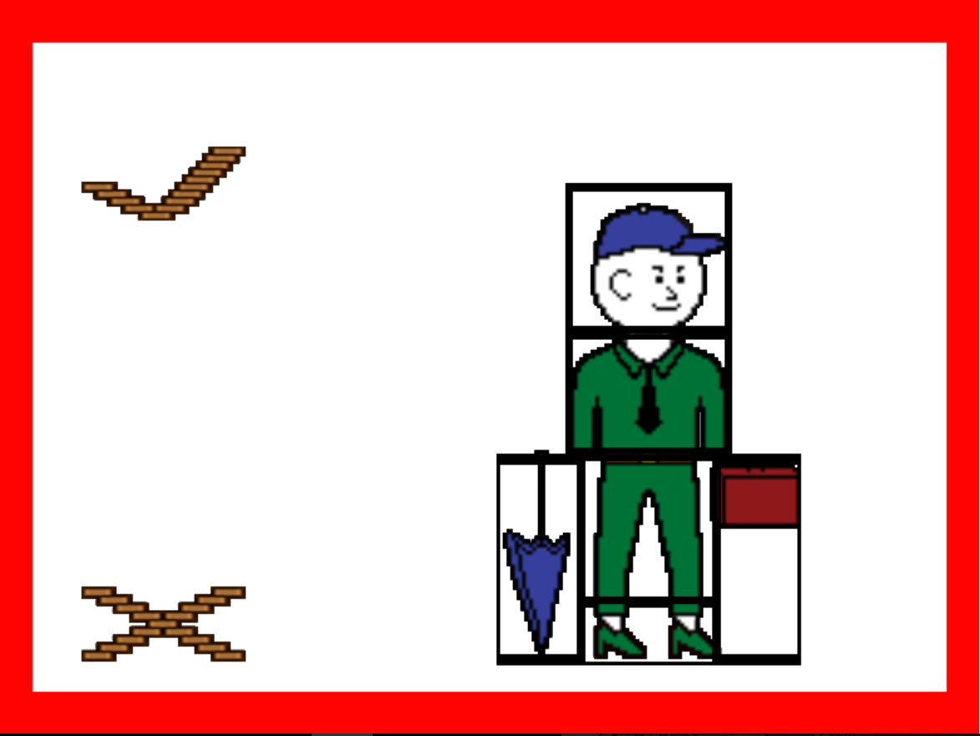

If you make a mistake, you can **click/touch** it again to go fix. Or you can hit the **X** button.

Once you select the shirt, **click/touch** the **checkmark** to confirm.

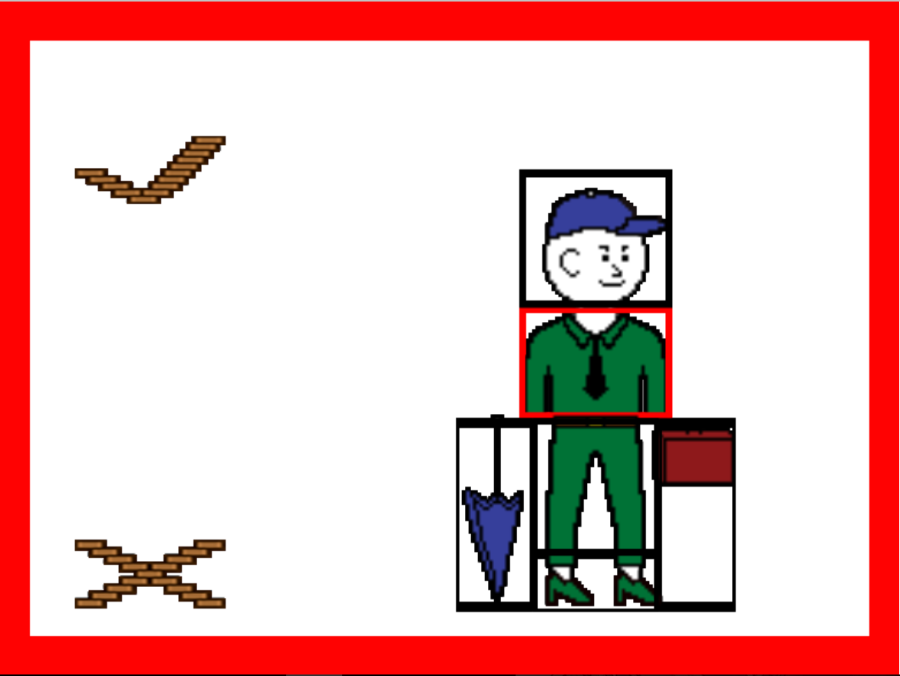

## 

## Confirm Pattern

Once you’ve confirmed the item, you will return to the game screen.  
Double check your selection by comparing the item above (in the **white box**) to the people in the line. Once you’re absolutely sure, click the **confirm button** to either proceed to the next level. If you chose incorrectly, you will instead be directed to the Game Over screen.

Repeat this process until you escape district 34!!!

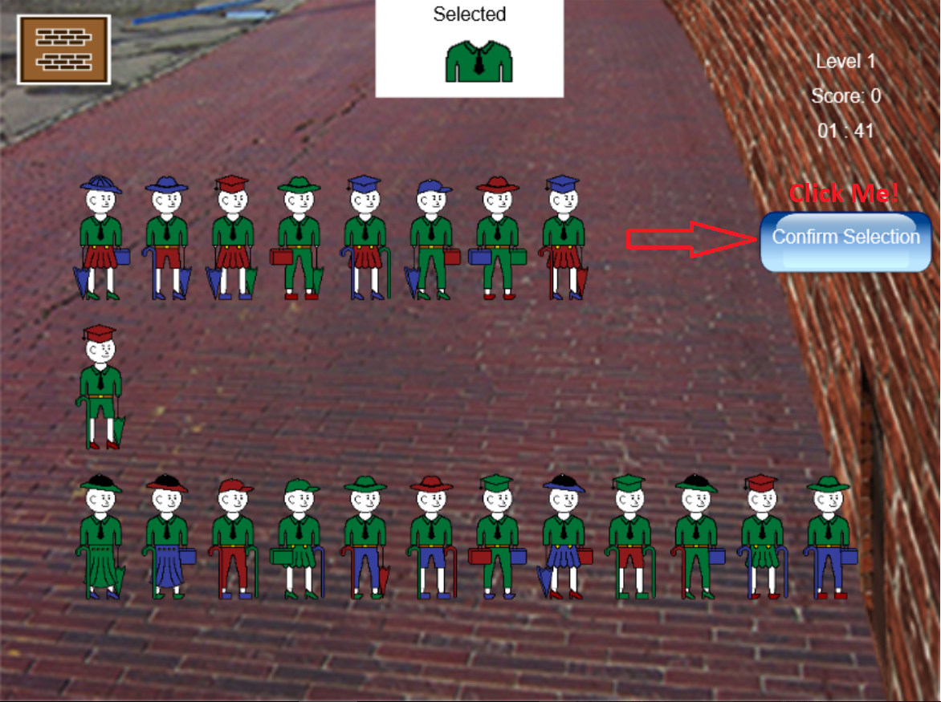

## Challenges

//time, rule complexity…

As the level increases, multiple factors change to make the game more difficult and fast - paced. The lines become shorter, the lines move faster, the time allowed decreases accordingly and, the level rules become more complicated. The game rules will become less obvious and there may be multiple rules for each level, requiring multiple items to be selected.

## Scoring

Based on how much time you take to beat each level. Each level you will get more points, and users will be ranked based on how many levels they beat and/or their points.

## 